Chapter 4 homework

- Complete exercises 4.3 (only b.-c.), 4.7 (only a. and c. using the Bonferroni procedure), and 4.27 (only a.-b. and d. using the Bonferroni procedure)
- Here is an inverse prediction problem from Graybill and Iyer (1994, p. 434-436)
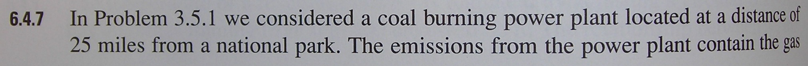
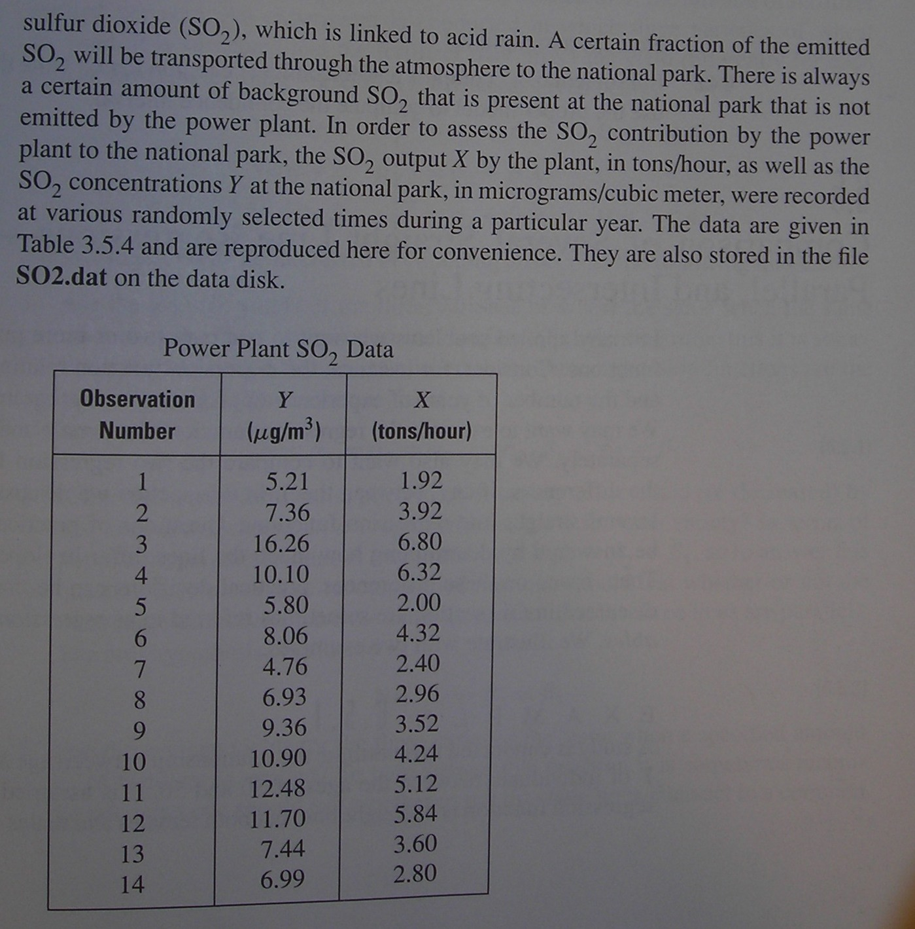

The data set is available on the Chapter 4 course materials web page. Suppose the park had a SO₂ concentration of 10.5 micrograms/cubic meter. Predict the SO₂ emission rate by the power plant. Use a 90% confidence interval for your prediction.
- Examine tests from 2012
- Reproduce all examples in the notes
Partial answers:

4.3 Here is my code and the corresponding output.

b.
> #################################################################################
> # 4.3b

> mod.fit<-lm(formula = minutes ~ copiers, data = copier)
> sum.fit<-summary(mod.fit)
> sum.fit

Call:
lm(formula = minutes ~ copiers, data = copier)

Residuals:
Min 1Q Median 3Q Max
-22.7723 -3.7371 0.3334 6.3334 15.4039

Coefficients:
Estimate Std. Error t value Pr(>|t|)
(Intercept) -0.5802 2.8039 -0.207 0.837
copiers 15.0352 0.4831 31.123 <2e-16 ***
---
Signif. codes: 0 '***' 0.001 '**' 0.01 '*' 0.05 '.' 0.1 ' ' 1

Residual standard error: 8.914 on 43 degrees of freedom
Multiple R-Squared: 0.9575, Adjusted R-squared: 0.9565
F-statistic: 968.7 on 1 and 43 DF, p-value: < 2.2e-16

> g<-2
> alpha<-0.05
> #Easiest way - you still need to understand the formulas!
> confint(object = mod.fit, level = 1 - alpha/g)
1.25 % 98.75 %
(Intercept) -7.092642 5.932329
copiers 13.913221 16.157275

I am at least 95% confident that β₀ is between -7.09 and 5.93 and β₁ is between 13.91 and 16.16.

c. These values can not be disproved since the values are within the interrvals. β₀ could be 0 and β₁ could be 14.

4.7 Using the Bonferroni procedure
a.

> more.copiers<-data.frame(copiers = c(3, 5, 7))
> g<-nrow(more.copiers)
> round(predict(object = mod.fit, newdata = more.copiers, interval =
"confidence", level = 1-alpha/g),2)
fit lwr upr
1 44.53 40.35 48.70
2 74.60 71.28 77.91
3 104.67 100.65 108.68

We are at least 95% confident that 40.35 < E(Y_{h}) < 48.70 for X_{h} = 3 copiers, 71.28 < E(Y_{h}) < 77.91 for X_{h} = 5 copiers, and 100.65 < E(Y_{h}) < 108.68 for X_{h} = 7 copiers.

b.

> more.copiers<-data.frame(copiers = c(4, 7))
> g<-nrow(more.copiers)
> round(predict(object = mod.fit, newdata = more.copiers, interval =
"prediction", level = 1-alpha/g),2)
fit lwr upr
1 59.56 38.59 80.53
2 104.67 83.63 125.71

We are at least 95% confident that 59.56 < Y_{h} < 80.53 for X_{h} = 4 copiers and 83.63 < Y_{h} < 125.71 for X_{h} = 7 copiers.

  - Do on your own. Below are partial answers:

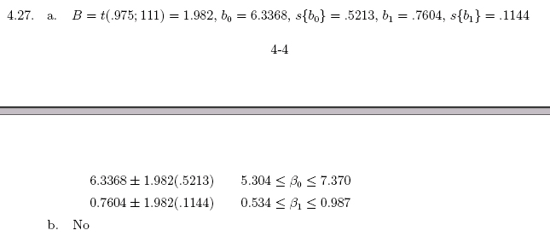
c.
> new.data = data.frame(infection = 2:5)
> round(predict(object = mod.fit, newdata = new.data, interval = "confidence", level = 0.95), 2)
fit lwr upr
1 7.86 7.24 8.47
2 8.62 8.19 9.05
3 9.38 9.07 9.69
4 10.14 9.80 10.48

Extra problem from Graybill and Iyer:

I obtain 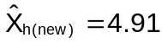 and a 90% C.I. of 3.36 < X_{h(new)} < 6.46.

